***Specimen Collection and Preparation***

Laboratory test results are dependent on the quality of the specimen submitted. It is important that all specimens and request forms be properly labeled with the name of the patient, collection date, and the origin (source) of the specimen, when appropriate.

**Specimen Collection**

The appropriate tube and volume will be indicated on the computer label. Check expiration dates on all collection tubes. **Do not** use expired products. If there is any doubt or question regarding the type of specimen that should be collected, it is imperative that the laboratory be called at 973-831-5204 to clarify the order and specimen requirements.

One patient’s specimens are sent, along with their extra labels, per specimen bag.

**Blood Bank Specimens**

Blood Bank specimens are to be drawn using the special Blood Bank armband in accordance to Clinical Policy: Blood and Blood Products Administration. A new specimen is required every 3 days when RBCs are being transfused. When a new specimen is drawn, the old armband is cut off and a new armband must be used.

If only blood products (platelets, fresh frozen plasma, or cryo) are to be transfused, 1 armband is needed per stay. (If RBCs are also required, use the current armband number.)

**Spinal Fluid**

No testing can be done on patients suspected of transmissible spongiform encephalopathy (TSE) such as Creutzfeldt-Jakob disease, bovine spongiform encephalopathy (BSE or mad cow disease).

**Specimen Collection Tubes**

The following is a list of tubes referred to in Chilton Medical Center’s specimen requirements:

**•**  *Dark-Green Top (Sodium Heparin)*: This tube contains sodium heparin—used for collection of sodium heparin plasma or whole blood for special tests.

**Note:** After tube has been filled with blood, immediately

invert several times to prevent coagulation.

**•**  *Gold Top (Serum Gel)*: This tube contains a clot activator and serum gel separator—used for various laboratory tests.

**Note:** Invert tube to activate clotting; let stand for 20 to

30 minutes before centrifuging for 10 minutes. If frozen serum is required, pour off serum into plastic vial and freeze. Do not freeze Vacutainer.

**•**  *Grey Top (Potassium Oxalate/Sodium Fluoride)*: This tube contains potassium oxalate as an anticoagulant and sodium fluoride as a preservative—used to preserve glucose in whole blood and for some special chemistry tests.

**Note:** After tube has been filled with blood, immediately

invert several times to prevent coagulation.

**•**  *Lavender Top (EDTA)*: This tube contains EDTA as an anticoagulant—used for most hematological procedures. **Note:** After tube has been filled with blood, immediately

invert several times to prevent coagulation.

**•**  *Light-Blue Top (Sodium Citrate)*: This tube contains sodium citrate as an anticoagulant—used for drawing blood for coagulation studies.

**Note:** It is imperative that the tube be completely filled.

The ratio of blood to anticoagulant is critical for valid prothrombin time results. Immediately after draw, invert tube 6 to 10 times to activate the anticoagulant.

**•**  *Plasma Gel (Light-Green Top) (Lithium Heparin)*: This tube contains lithium heparin—used for collection of lithium heparin plasma or whole blood.

**Note:** After tube has been filled with blood, immediately invert several times to prevent coagulation.

**•**  *Red Top*: This tube is a plain Vacutainer containing no anticoagulant—used for collection of serum for selected chemistry tests as well as clotted blood for immunohematology.

**•**  *Royal-BlueTop*: There are 2 types of royal blue-top Monoject tubes—1 with the anticoagulant EDTA and the other plain. These are used for collection of whole blood or serum for trace element analysis. Refer to individual metals in individual test listings to determine tube type necessary.

**•**  *Special Collection*: Some tests require specific tubes for proper analysis. Please contact Chilton Medical Center prior to patient draw to obtain correct tubes for metal analysis or other tests as identified in individual test listings.

**•**  *Yellow-Top (ACD)*: This tube contains ACD—used for drawing whole blood for special tests.

**Specimen Labeling**

**•** Laboratory specimens should be labeled with computer generated bar code labels whenever possible (except for Blood Bank specimens).

**•** Specimens must be labeled at the collection site by the person collecting the specimen.

**•** Affix label to the specimen as soon as collected. If these printed labels are not available, the specimen must be hand labeled or a chart label may be used.

**•** Specimens must never be transported from the collection site unlabeled.

**•** Blood collection tubes or specimen containers must never be pre-labeled.

**Collection Labels**

There are 2 types of labels:

1. Specimen labels, which are used to label specimens drawn, and contain a bar code.

2. Collection labels which give patient and order information.

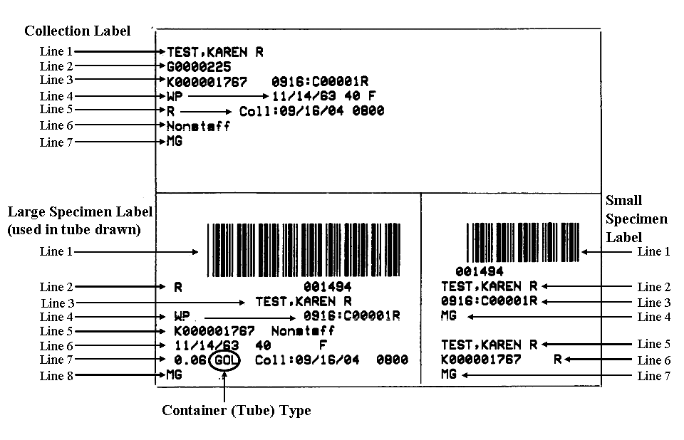

*Descriptions*:

**Collection Label: (bottom left)** Line 1: Bar code symbol Line 2: Priority, bar code # Line 3: Patient’s name

Line 4: Patient’s location, accession (specimen) number

Line 5: Registration (stay) #, admitting MD Line 6: Date of birth, age, sex

Line 7: Specimen volume needed, collection container required (abbreviation), collection date and time

Line 8: Test ordered

**Aliquot Label (lower right)**

Line 1: Barcode #

Line 2: Patient’s name Line 3: Accession # Line 4: Test ordered Line 5: Patient’s name

Line 6: Patient’s billing #, priority

Line 7: Test ordered

**Large Label (top left)** Line 1: Patient’s name Line 2: Medical record #

Line 3: Patient stay #, accession #

Line 4: Phlebotomist’s employee number, time of collection must be written on all tubes

Line 5: Priority, collection date and time

Line 6: Admitting physician

Line 7: Procedure ordered

**Note:** 1. Bar code must be parallel on tube with patient’s name starting toward top of tube. THERE IS 1 BARCODE FOR EACH SPECIMEN THAT IS TO BE DRAWN. If this rule is not followed there may not be enough specimen to process.

2. Do not use aliquot labels (remove from bar code label). These are only used on “just in case” tubes.

3. Use correct label on correct color top tube. Tube color abbreviations are found on specimen labels.

4. Phlebotomist’s employee number must be written on all tubes.

5. Return all unused labels to laboratory with specimen.

6. Most common blood collection tubes:

|  |  |
| --- | --- |
| **Container Description** | **Abbreviation on Label** |
| Lavender-top tube | Lav |
| Red-top tube | Red |
| Light green-top tube | LTGRN |
| Blue-top tube | Blu |
| Gold-top tube | Gol |